
SRM Institute of Science and Technology
Mode of Exam
OFFLINE
College of Engineering and Technology
School of Computing
DEPARTMENT OF COMPUTING TECHNOLOGIES
SRM Nagar, Kattankulathur – 603203, Chengalpattu District, Tamilnadu
Academic Year: 2021-2022 (EVEN)
Test: CLAT-1 Date: 4-4-2022
Course Code & Title: 18CSC205J: Operating systems Duration: 1 Period
Year & Sem: II & IV Max. Marks: 25 Marks

Course Outcomes (CO): |  |  |  |  |  |  | At the end of this course, learners will be able to:
CO-1 : |  | Express the fundamental concepts in operating system
Program Outcomes (PO)
1 | 2 |  | 3 | 4 | 5 | 6 |  | 7 | 8 | 9 | 10 | 11 | 12 | PSO
Engineering Knowledge | Problem Analysis |  | Design & Development | Analysis, Design, Research | Modern Tool Usage | Society & Culture |  | Environment & Sustainability | Ethics | Individual & Team Work | Communication | Project Mgt. & Finance | Life Long Learning | PSO - 1 | PSO - 2 | PSO – 3
3 |  |  | 3 |  |  |  |  |  |  |  |  |  |  | 2

Part - A
(5 x 1 = 5 Marks)
Instructions: Answer all
Q. No | Question | Marks | BL | CO | PO | PI Code
1 | Multiprocessor system that computer systems have are also called  - Parallel Systems  - Tightly couple system  - loosely couple system  - Both A and B | 1 | 1 | 1 | 1 | 1.6.1
2 | Thread scheduling of operating system programs is done by  - Input  - Output  - Operating system  - Memory | 1 | 1 | 1 | 1 | 1.6.1
3 | Multiprogramming of computer system increases  - memory  - Storage  - CPU utilization  - Cost | 1 | 1 | 1 | 1 | 1.6.1
4 | Consider the following code fragment:  if (fork() == 0)  { a = a + 5; printf("%d,%dn", a, &a); }  else { a = a –5; printf("%d, %dn", a, &a); }  i) Let u, v be the values printed by the parent process, and x, y be the values printed by the child process. Which one of the following is TRUE?  A. u = x + 10 and v = y  B. u = x + 10 and v != y  C. u + 10 = x and v = y  D. u + 10 = x and v != y | 1 | 1 | 1 | 1 | 1.6.1
5 | Less-privileged mode in the mode of processor execution normally associated with the operating system is often referred to as the …………… mode.  A. user mode  B. un-restricted mode  C. Both A and B  D. None of the above | 1 | 1 | 1 | 1 | 1.6.1
Part – B
(5 x 4 = 20 Marks)
Instructions: Answer any 5
6 | With a neat sketch illustrate Operating System as Resource Manager | 4 | 3 | 1 | 3 | 2.6.2
7 | Compare Effects on Resource Utilization with uni-programming and multi-programming | 4 | 4 | 1 | 2 | 2.6.4
8 | Write short notes on Compatible Time-Sharing Systems | 4 | 3 | 1 | 1 | 1.7.1
9 | Summarize the importance of threads | 4 | 2 | 1 | 1 | 1.7.1
10 | With a neat sketch relate Tree of Processes in Linux | 4 | 3 | 1 | 3 | 2.6.2
11 | Explain about process termination. | 4 | 2 | 1 | 1 | 1.7.1

Course Outcome (CO) and Bloom’s level (BL) Coverage in Questions

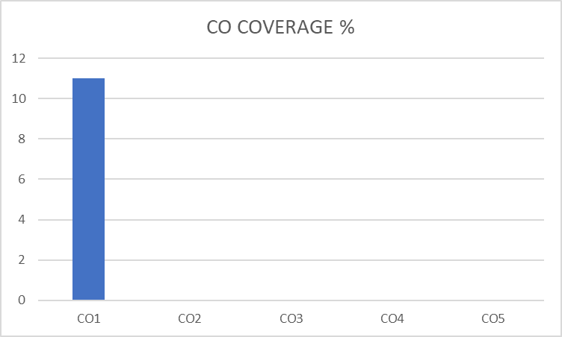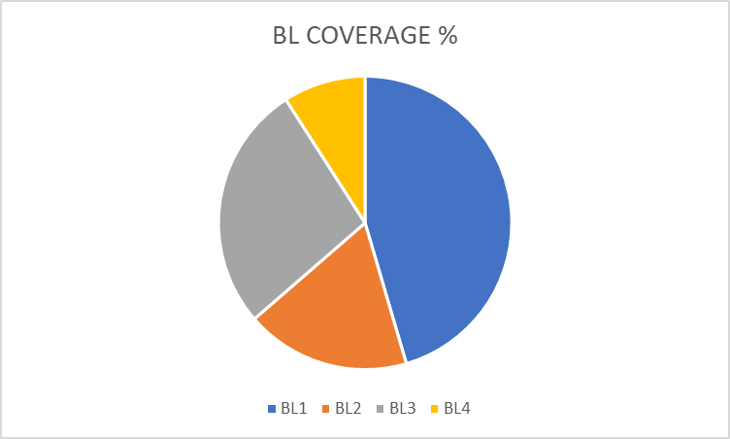

Approved by the Audit Professor/Course Coordinator

